**CTO Candidate Task Presentation**

Strategic Planning and Team, Architecture, and

Tech Stack Evaluation

By

Yoganand Aiyadurai

Version 1.0

Dated: 14th August 2024

**Slide 1 - Team Evaluation and Restructuring**

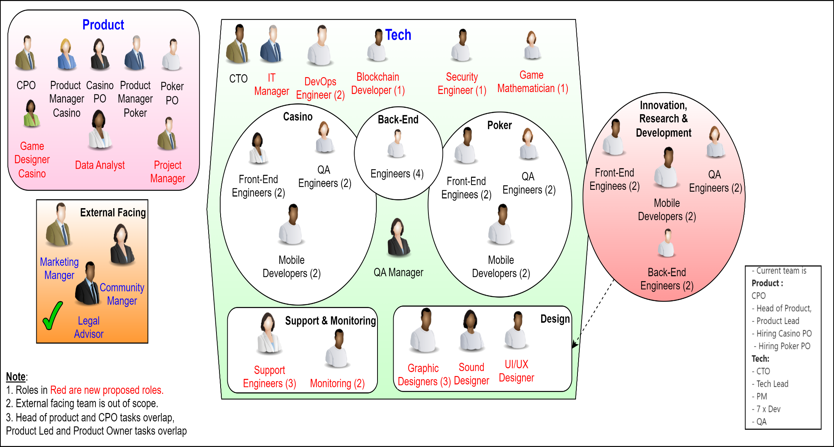

## Figure 1 Team restructuring

**Slide 2 – Architecture Assessment and Improvements**

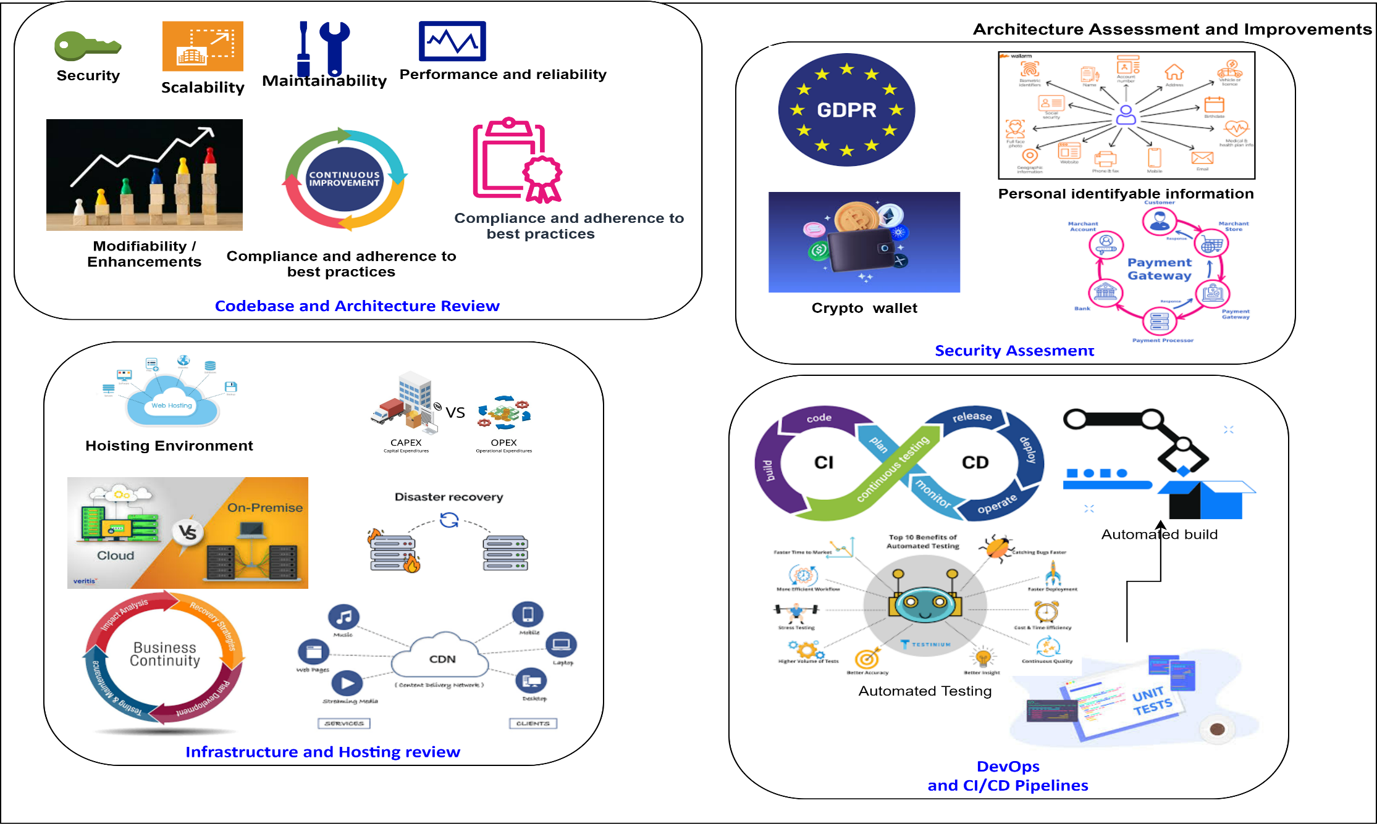

## Figure 2 Architecture Assessment and Improvements

**Slide 3 -** **Tech Stack Review and Modernization**